
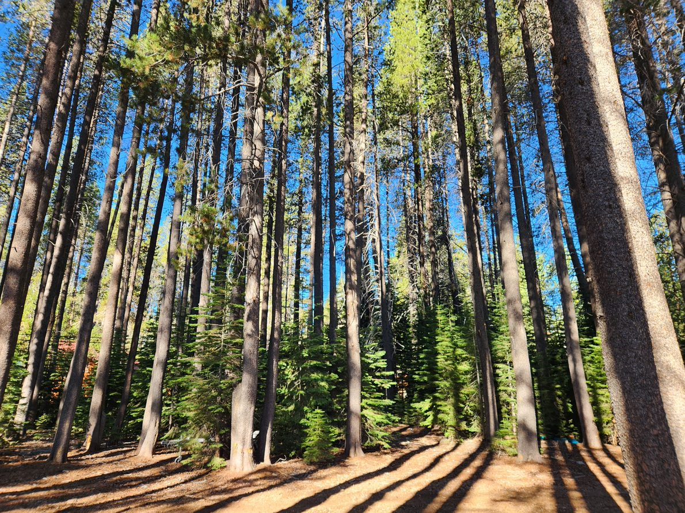
2025 Microgrant final report

Please report on the length (feet or miles) and area (acres) that were treated as a result of this project.

Please provide your post-implementation photo points (3).

Please provide a brief narrative of the project outcome.

Did you experience any significant issues? If so, please describe them.

