Site 5 Factsheet
Opportunity: APN 035-412-018 – 11840 Ranchview Court, 4.5 acres, potential for 90 units, w/bonus density could add 22 additional units.
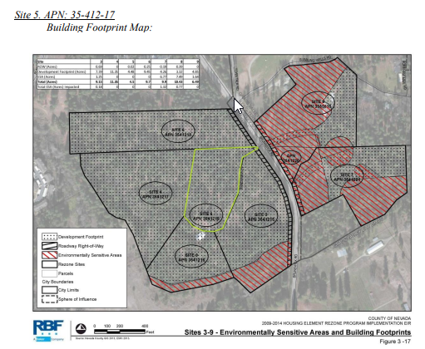

Description/Surrounding Land Uses:
Site 5 is located on Brunswick Road, north of Idaho Maryland Road and south of Bubbling Wells Road. Sites 3, 5 and 6 are on the west side of Brunswick Road and are accessed by Triple Crown Drive. The Nevada County Airport is located approximately one half mile to the southeast. Due to the proximity to the airport, all of these sites are also located within the Nevada County Airport Influence Area.
Infrastructure:
Infrastructure: Site 5 has direct frontage along Brunswick Road, a publically maintained roadway. Public water is provided to the site via an existing 18” line that is located in the Brunswick Road right of way. Public sewer would need to be provided by the City of Grass Valley, and subsequently this site would need to be annexed to the City prior to developing. As with all of the other sites, it is the burden of the future developer to ensure that adequate capital facilities (sewer lines/pump or lift stations, etc.) are in place and that adequate capacity is available at the City’s wastewater treatment plant to service the project.
Common utilities such as PG&E electrical and AT&T phone/internet as well as cable television are available to be extended to the site. Services: Site 5 is served by the Nevada County Sheriff for police services and the Nevada County Consolidated Fire District for fire protection and safety services. Once annexed, the City of Grass Valley would be responsible for providing these services.
Site 5 is within walking distance (approximately ½ mile) to the Sutton Way/Brunswick Road commercial area, which provides a wide variety of urban services with several options to choose from including bus stops that link the area to other locations in the city and the County. As a result there adequate services to serve future populations associated with development of the rezone candidate sites in the region.
Access: Site 5 has road frontage along Brunswick Road. Mitigation Measure 4.15-4 requires that future access to Site 5 be aligned with Town Talk Road to establish a new signalized intersection at Brunswick Road near the northeast corner of Site 6. This new intersection will serve the internal access roads for sites 3-6 and 9.
Land Use/Density: At 4.05-acres, the General Plan Designation/zoning for Site 5 is Urban High Density (UHD)/R3-RH. Through the environmental review process, it has been determined that Site 5 is free from any environmental constraints that would limit the full build-out of the site. Subsequently, the site has a developable footprint of 4.48-acres after removing the anticipated right of way dedication, which at the minimum density of 16-units per acres would result in the potential density of 90-units and will likely be one to three story apartments or condominiums. Should the property owner elect to pursue a density bonus consistent with LUDC Sec. L-II 3.16 and/or Section L-II 3.20 (or more likely consistent with the provisions of the City of Grass Valley’s codes and regulations), the allowable density bonus (up to 25% depending on specific provisions allowed by ordinance) could add an additional 22-units to a future multi-family housing project.
Parking: The number of required parking spaces associated with the future multi-family development of the site would be subject to the City of Grass Valley’s parking requirements, as it is assumed this site would have to be annexed to be built as high density housing. For discussion purposes, utilizing the County’s parking requirements, the range of required parking spaces (based on the density of 90-units) would be anywhere from 90-spaces (if all units were 1 bedroom units or restricted to be senior or disabled housing) up to 225-spaces (if all units were 3 bedroom units).
Environmental Resources: Site 5 is an undeveloped property that is completely surrounded by other properties within the study area (Sites 3, 4, 6, and 9). This site is situated on a low hilltop knoll and supports a Sierran mixed conifer forest type. The site slopes in all directions away from the top of the knoll. No defined hydrologic features occur on this site. For greater detail regarding environmental resources, including how potential impacts will be mitigated, please refer to the Draft EIR Section 4.4: Biological Resources and Appendix E of the Technical Appendices: Mitigation-Monitoring-and-Reporting-Program-PDF
Mitigation Measures/Development Standards: The following Mitigation Measures shall be required to be met prior to development on Site 5:
Land Use and Planning: Mitigation Measure 4.2-1
Aesthetics: Mitigation Measures 4.3-1, 4.3-3, 4.3-4
Biological Resources: Mitigation Measures 4.4-1b, 4.4-1c, 4.4-2a, 4.4-2b, 4.4-2c, 4.4-1a, 4.4-3a, 4.4-3b
Air Quality: Mitigation Measures 4.5-1a, 4.5-1b, 4.5-1c, 4.5-2a, 4.5-2b, 4.5-2
Cultural Resources: Mitigation Measures 4.7-2, 4.7-3
Geology and Soils: Mitigation Measures 4.8-1, 4.10-1b, 4.8-3
Hazards and Hazardous Materials: Mitigation Measures 4.9-4, 4.13-1b, 4.13-1c
Hydrology and Water Quality: Mitigation Measures 4.10-1b, 4.10-1c, 4.10-1d, 4.10-1c
Noise: Mitigation Measures 4.11-1a, 4.11-1b, 4.11-2
Public Services, Utilities and Service Systems: Mitigation Measures 4.13-1a, 4.13-1b, 4.13-1c, 4.13-2, 4.13-3
Recreation: Mitigation Measure 4.14-1
Transportation and Traffic: Mitigation Measures 4.15-2, 4.15-4, 4.15-7, 5.2.14-1, 5.2.14- 2

For further information please contact:

Kimberly Parker
Economic Development Office
County of Nevada
950 Maidu Avenue
Nevada City, CA 95959
Kimberly.parker@nevadacountyca.gov
(530) 470-2795 office
(530) 913-1354 cell
www.nevadacountyca.gov.
www.gonevadacounty.com



