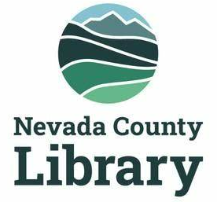

LIBRARY MEASURE A
CITIZENS’ OVERSIGHT COMMITTEE

AGENDA: July 14, 2025, 3:00pm
211 N. Pine Street Nevada City CA 95959 and via video conference
https://us02web.zoom.us/j/89891678826?pwd=s01omKqH0pq3GJVVFaUPvY8lcdRmDj.1
______________________________________________________________________________
Agenda for the regular meeting of the Citizen’s Oversight Committee (COC) of the Nevada County Library, scheduled for Monday, July 14, 2025 at 3:00 p.m. at the Doris Foley Library and via video conference.

Clerk of the Committee: Nick Wilczek, County Librarian

- Call Meeting to Order
- Establishment of a quorum, roll call – Corinne Benson
- Approval of the agenda
- Approval of the minutes of COC Meeting, April 21, 2025
- Public comment
- County Librarian report on Measure A expenditures—Nick Wilczek
- Discussion of report to Nevada County Board of Supervisors—Michael Leydon, Michael Hill-Weld
- Adjourn meeting

