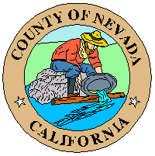
Penn Valley Municipal Advisory Council (PVMAC)
PUBLIC NOTICE – MEETING CANCELED
To receive an email notice when the agenda is posted: www.mynevadacounty.com/list.aspx
(under Agenda Center, select Penn Valley Area Municipal Advisory Council)

Date: Thursday, January 15, 2025
Time: 6:00 p.m.
Place: N/A

Members:
Douglas Moon, Chair
Patricia Rockwell, Vice Chair
Mark Bailey, Member
Lisa Duggins-Rogers, Member
Bob Winters, Member
Laura Zieman, Member
Vacant, Member
Vacant, Member
Vacant, Member

Penn Valley Area Municipal Advisory Council
Canceled: Regular Meeting, scheduled for January 15, 2026

AFFIDAVIT OF POSTING
Meeting notice/agenda of the PVMAC meeting, scheduled for January 15, 2026, was posted per open meeting law requirements at the following locations:
Eric W. Rood Administrative Center, 950 Maidu Avenue, Nevada City CA
Penn Valley True Value located at 17387 Penn Valley Drive, Penn Valley CA
Penn Valley Shopping Center located at 17464 Penn Valley Drive, Penn Valley CA
www.mynevadacounty.com

AGENDA POSTED: Thursday, December 18, 2025

