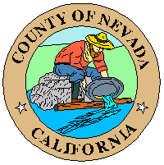
South County Area Municipal Advisory Council (SCMAC)
PUBLIC NOTICE – MEETING CANCELED
To receive an email notice when the Agenda is posted: www.nevadacountyca.gov
(under Agenda Center select South County Area Municipal Advisory Council)

Date: Wednesday January 15, 2025
Time: 6:00 p.m.
Place: N/A

Members:
James Mathias, Chair
Jeff Pettitt, Vice-Chair
Vicki Hawkins, Member
MaryJane Huenergardt, Member
Jake Jacobson, Member
Laura Barhydt, Member
Gary Baker, Member
Jamie Jones, Alternate Member
Vacant, Member
Vacant, Member
Vacant, Alternate Member

South County Area Municipal Advisory Counsel
Canceled: Regular Meeting, scheduled for January 15, 2025

AFFIDAVIT OF POSTING
Meeting Notice/Agenda of the SCMAC meeting, scheduled for January 15, 2025 was posted per Open Meeting Law requirements at the following locations:
- Eric W. Rood Administrative Center, 950 Maidu Avenue, Nevada City CA
- www.NevadaCountyCA.gov
- Higgins Lions Community Center, 22490 East Hacienda Dr., Grass Valley, CA 95949

AGENDA POSTED: January 13, 2025

