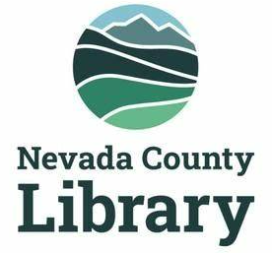

LIBRARY MEASURE A OVERSIGHT COMMITTEE

AGENDA: January 13, 2025, 3:00pm
______________________________________________________________________________
Agenda for the regular meeting of the Citizen’s Oversight Committee (COC) of the Nevada County Library, scheduled for Monday, January 13, 2024, 3:00 p.m. at the Doris Foley Library and via video conference.
https://us02web.zoom.us/j/89259927211?pwd=pP2N8rMZ9aMPDqQaEyGVMztHMuVqQd.1M
Meeting ID: 892 59927211
Passcode: 787895

Clerk of the Committee: Nick Wilczek, County Librarian

- Call Meeting to Order
- Establishment of a quorum, roll call – Corinne Benson
- Approval of the agenda
- Approval of the minutes of COC Meeting, January 13, 2025
- Public comment
- Set calendar for meetings for 2025
- County Librarian report on Measure A expenditures—Nick Wilczek
- Discussion of report to Nevada County Board of Supervisors—Michael Leydon
- Election of a Board Secretary
- Adjourn meeting

